Gift Aid declaration – for past, present & future donations  Name of charity or Community Amateur Sports Club: | 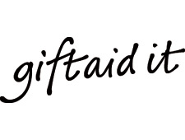
Kono District Development Association UK (KDDA UK)
Please treat as Gift Aid donations all qualifying gifts of money made
today in the past 4 years in the future
Please tick all boxes you wish to apply.
I confirm I have paid or will pay an amount of Income Tax and/or Capital Gains Tax for each tax year (6 April to 5 April) that is at least equal to the amount of tax that all the charities or Community Amateur Sports Clubs (CASCs) that I donate to will reclaim on my gifts for that tax year. I understand that other taxes such as VAT and Council Tax do not qualify. I understand KDDA UK will reclaim 28p of tax on every £1 that I gave up to 5 April 2008 and will reclaim 25p of tax on every £1 that I give on or after 6 April 2008.
Donor’s details:
Title |  | Initials | Forename (s) |  |  | Surnames
Full Home Address
Post Code |  |  |  | Date
Signature
Please notify the charity or CASC if you:
- Want to cancel this declaration
- Change your name or home address
- No longer pay sufficient tax on your income and/or capital gains.
If you pay Income Tax at the higher or additional rate and want to receive the additional tax relief due to you, you must include all your Gift Aid donations on your Self-Assessment tax return or ask HM Revenue and Customs to adjust your tax code.

